Log in to AWS Console using Sandbox:

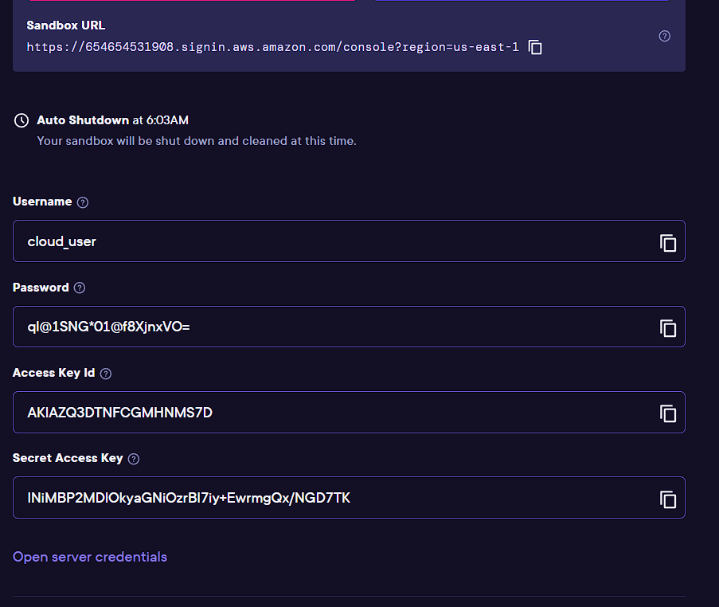

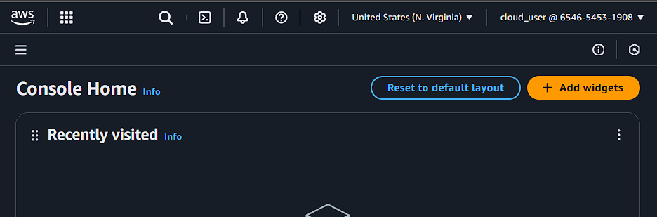

Login to your AWS CLI:

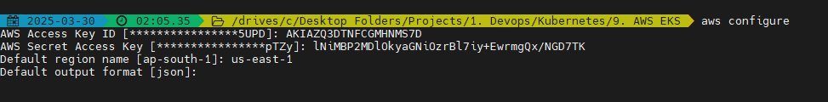

Make sure you have eksctl and kubectl installed

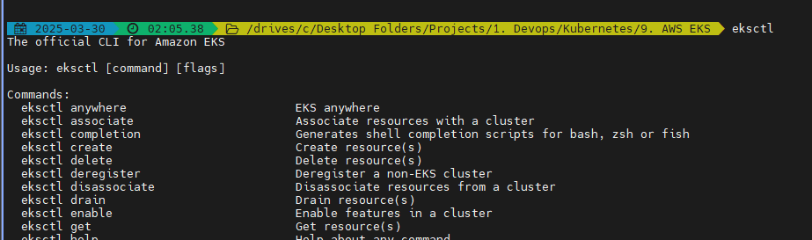

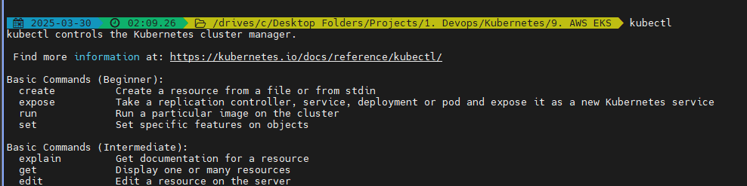

Now we start by creating a cluster:

* eksctl create cluster --name=faraz-2048 --region=us-east-1 –fargate



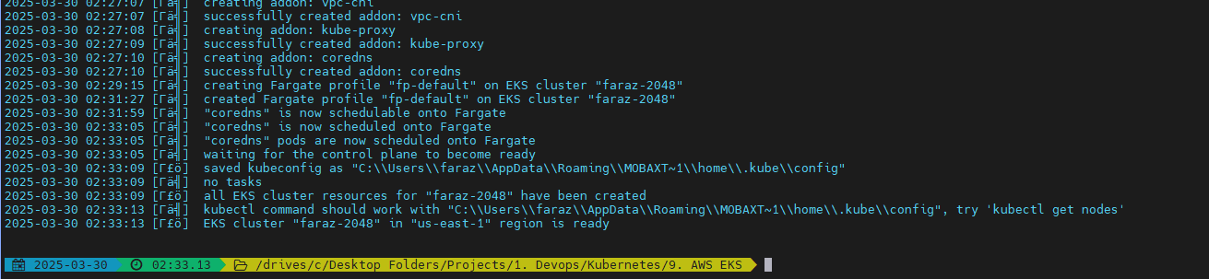

Verify on the console:

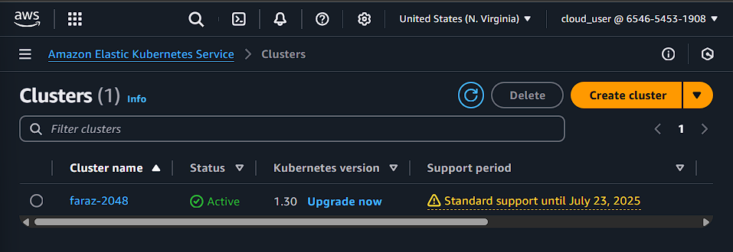

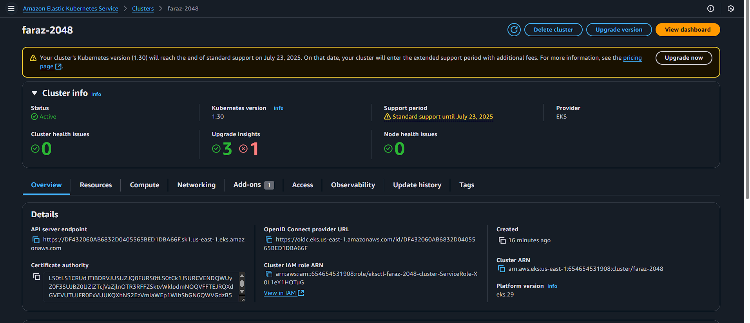

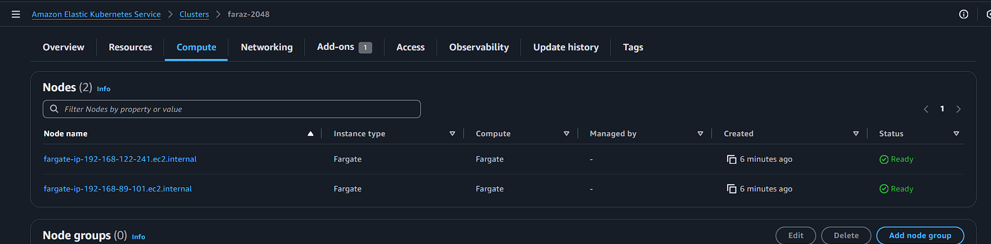

Now if I want my aws configurations of the cluster locally:

* aws eks update-kubeconfig --name faraz-2048 --region us-east-1

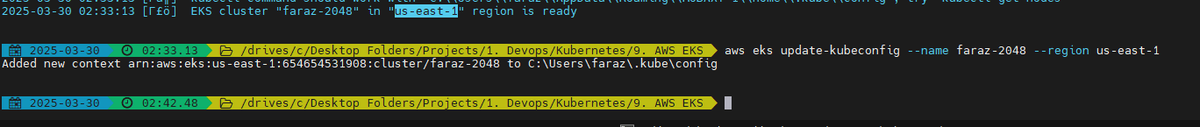

Now create a fargate profile in a namespace:

* eksctl create fargateprofile --cluster faraz-2048 --region us-east-1 --name faraz-alb-sample-app --namespace faraz-game-2048-namespace



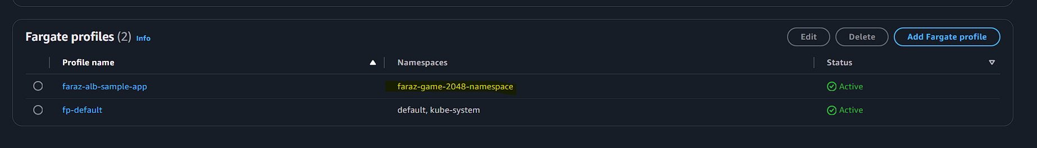

* Every time using fargate we use namespace

Now copy paste from: <https://raw.githubusercontent.com/kubernetes-sigs/aws-load-balancer-controller/v2.5.4/docs/examples/2048/2048_full.yaml>

Edit the yaml deployment, service and ingress as per your namespace and desired name for resources

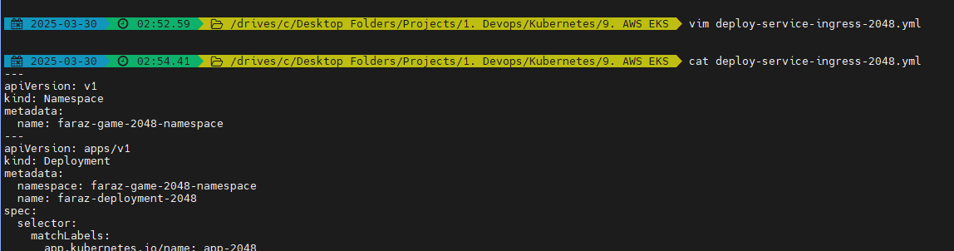

Wait for the resources to get created:

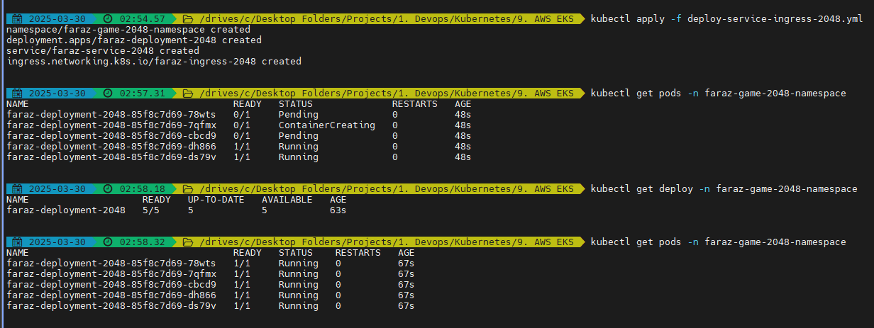

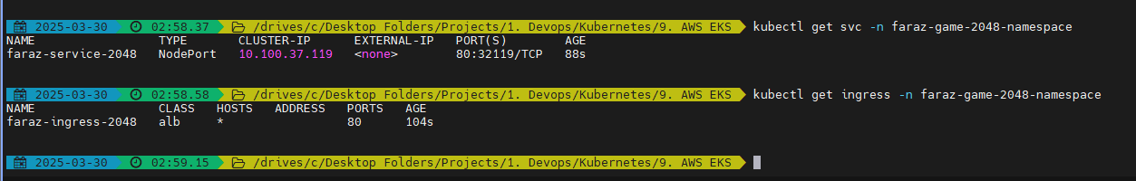

Now here we can see the Address field is not populated as there is no ingress controller and Application Load balancer

Application load balancer which is AWS service will require OIDC connection to talk to ingress controller -> Service -> Deployment -> Pods or the K8s services. Hence create the OICD connection

* eksctl utils associate-iam-oidc-provider --cluster faraz-2048 –approve



ALB controller (Pod) needs access to communication to AWS services

Now you can use the IAM policy provided in:

<https://raw.githubusercontent.com/kubernetes-sigs/aws-load-balancer-controller/v2.11.0/docs/install/iam_policy.json>

Create the IAM policy:

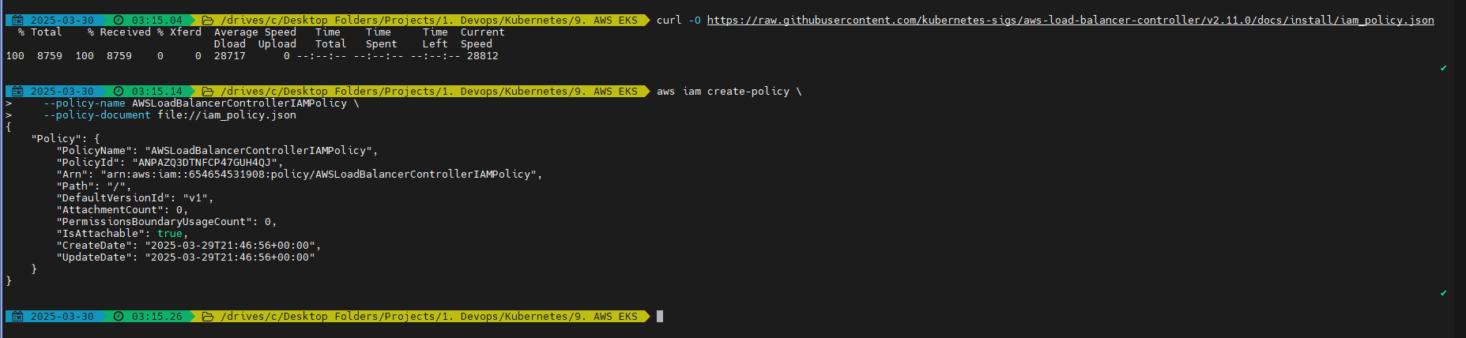

Now create the service role:

eksctl create iamserviceaccount --cluster=faraz-2048 --namespace=kube-system --name=aws-load-balancer-controller --role-name AmazonEKSLoadBalancerControllerRole --attach-policy-arn=arn:aws:iam::654654531908:policy/AWSLoadBalancerControllerIAMPolicy –approve

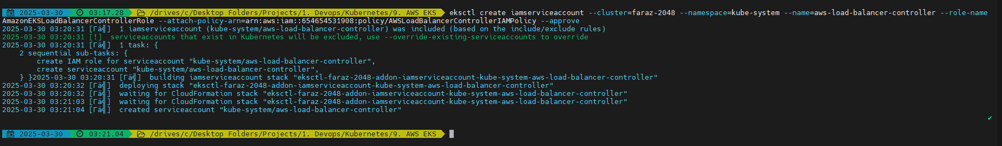

Now we will create the ALB controller:

* helm repo add eks <https://aws.github.io/eks-charts>
* helm repo update eks

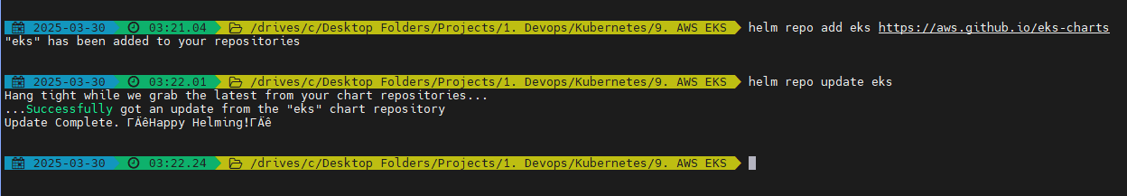

* helm install aws-load-balancer-controller eks/aws-load-balancer-controller -n kube-system --set clusterName=faraz-2048 --set serviceAccount.create=false --set serviceAccount.name=aws-load-balancer-controller --set region=us-east-1 --set vpcId=vpc-03d0000c4afea61d7

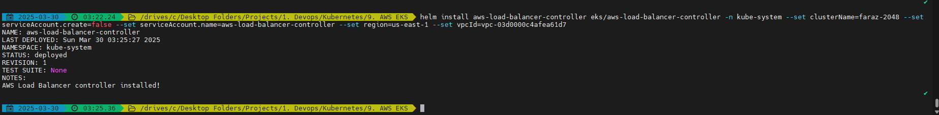

Verify the Load balancer controller which is deployed in 2 AZs

* kubectl get deployment -n kube-system aws-load-balancer-controller

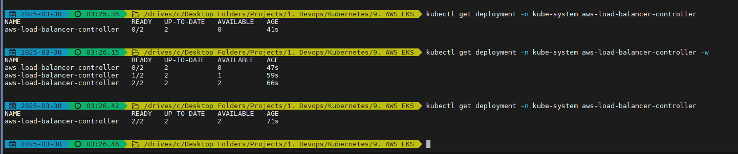

Verify on console:

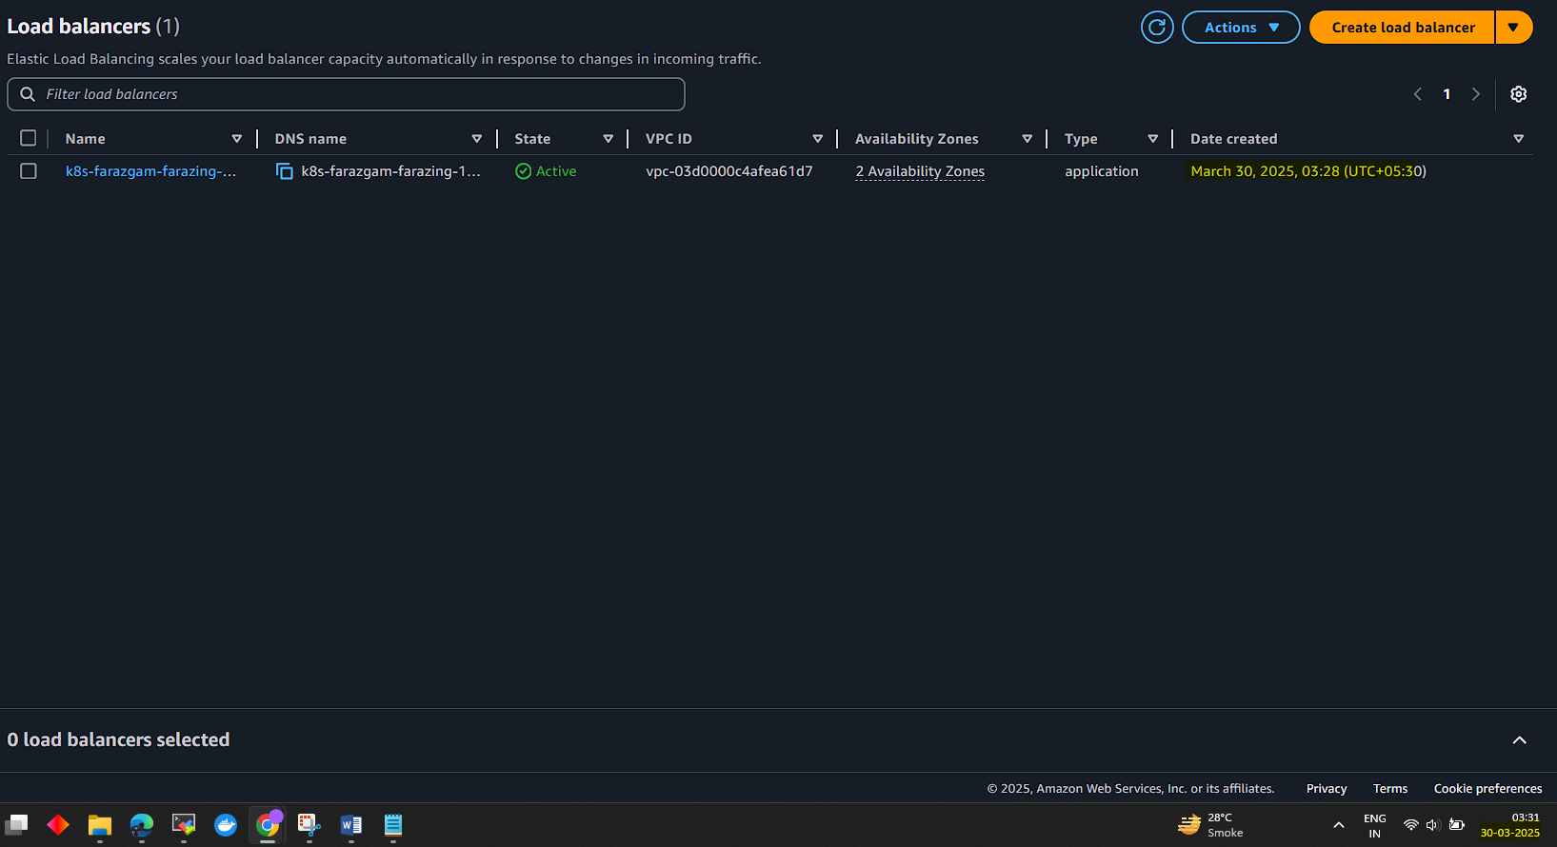

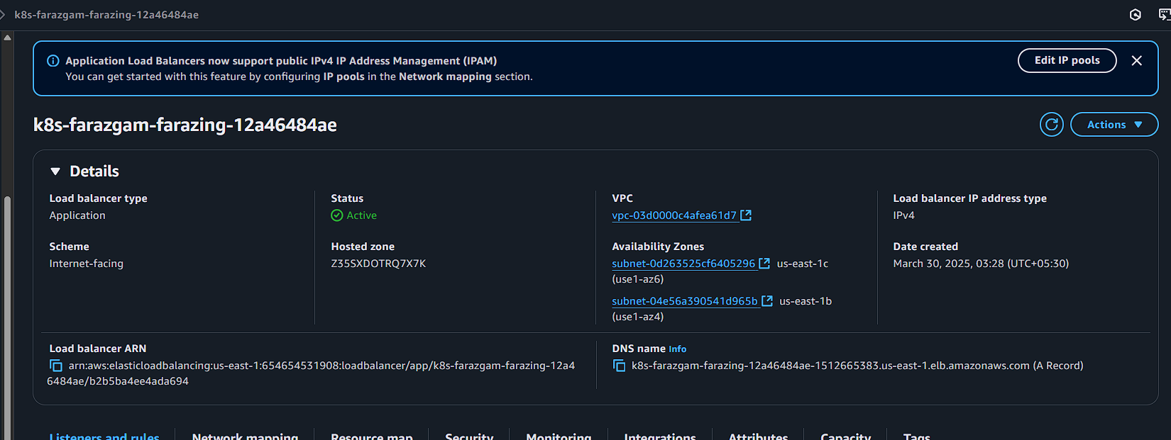

Now you will be able to see:



Now the address is populated. This address is the Loadbalancer address

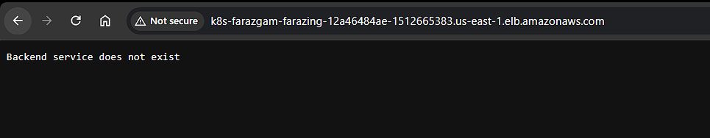

This is because of: 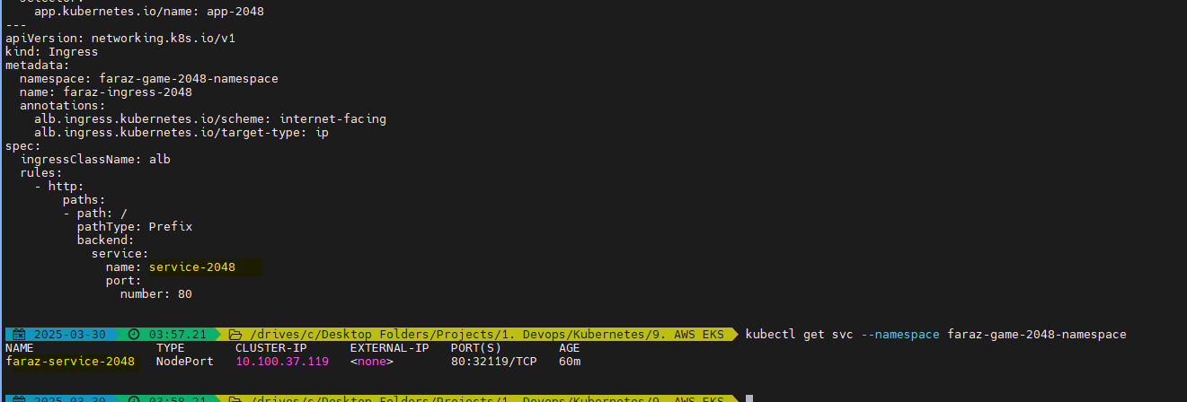

Restart your deployment:

* kubectl rollout restart deployment aws-load-balancer-controller -n kube-system

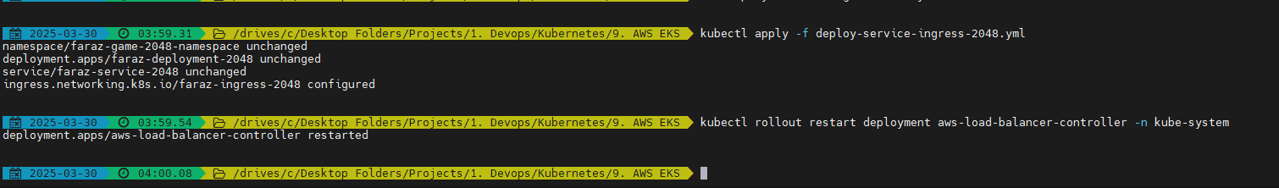

Validate on Web:

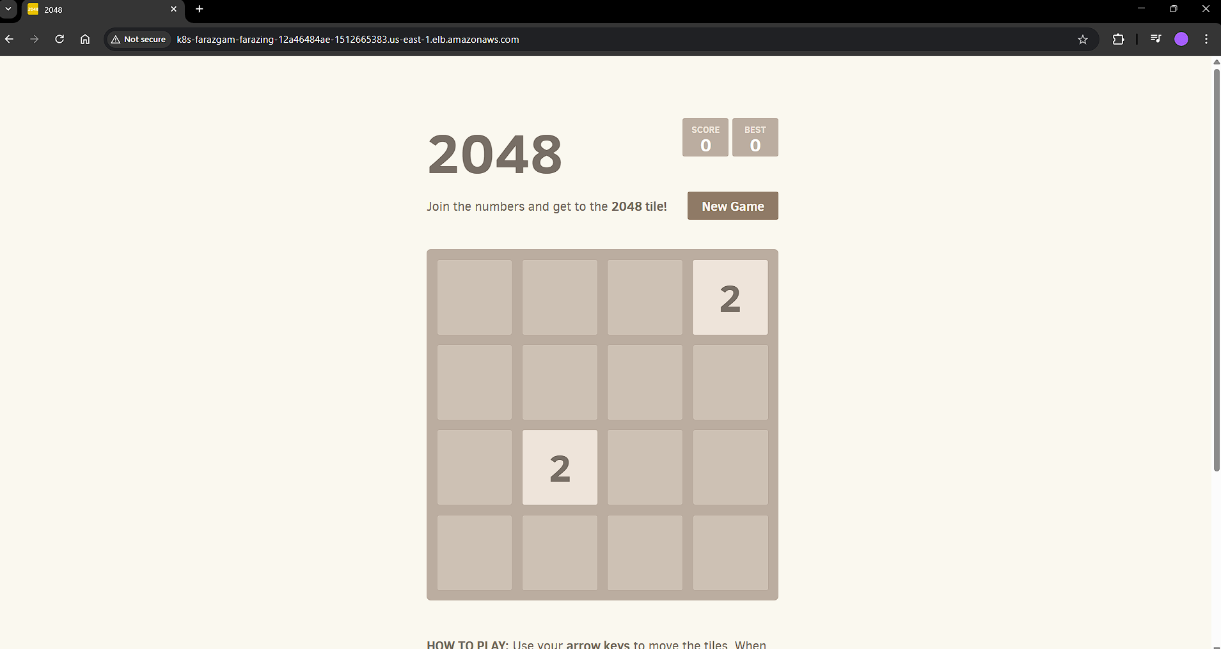

Play the game:

